**FINAL EXAM STATPROB**

**OLEH:**

**I MADE GILANG ARYDHANA RAHJASA (2415091115)**

**PROGRAM STUDI SISTEM INFORMASI**

**JURUSAN TEKNIK INFORMATIKA**

**FAKULTAS TEKNIK DAN KEJURUAN**

**UNIVERSITAS PENDIDIKAN GANESHA**

**SINGARAJA**

**2024**

THE QUESTION

**FINAL PROJECT**

**COURSE : STATISTICS AND PROBABILITY**

**INFORMATICS EDUCATION STUDY PROGRAMME**

Date : December 25, 2024

Time : -

Exam Type : *Open Book*

Name : I MADE GILANG ARYDHANA RAHJASA

NIM : 2415091115

Class : IKI SI 24

Create a simple simulation in R to perform one of the following statistical analyses:

• Simple Linear Regression

• Correlation Analysis

• ANOVA

• Multiple Linear Regression

This project aims to help you understand statistical concepts and apply them programmatically. The results will be uploaded to a **GitHub** repository.

Principle:

1. Data
2. Uji asumsi (min 3)
3. Analisis
4. Visualisasi
5. Interpretasi

THE ANSWER

1. DATA

|  |  |  |  |  |
| --- | --- | --- | --- | --- |
| **ID** | **Genre** | **Play_time** | **Age** | **Income** |
| 1 | Strategy | 9.2 | 28 | 356900 |
| 2 | Shooter | 8.7 | 35 | 434600 |
| 3 | RPG | 5 | 27 | 489500 |
| 4 | Shooter | 1.9 | 20 | 573300 |
| 5 | Shooter | 4.3 | 24 | 686300 |
| 6 | Adventure | 7 | 33 | 362500 |
| 7 | RPG | 7 | 33 | 635900 |
| 8 | RPG | 6.3 | 37 | 590100 |
| 9 | RPG | 3.5 | 34 | 468600 |
| 10 | Shooter | 6.1 | 19 | 600900 |
| 11 | Strategy | 4.4 | 18 | 671000 |
| 12 | RPG | 9.7 | 33 | 315400 |
| 13 | Shooter | 8.6 | 29 | 553700 |
| 14 | Adventure | 7.5 | 22 | 440900 |
| 15 | Strategy | 3.1 | 22 | 378400 |
| 16 | Adventure | 3.3 | 26 | 617500 |
| 17 | Strategy | 1.4 | 26 | 646400 |
| 18 | Shooter | 7.4 | 20 | 688200 |
| 19 | Action | 2 | 36 | 324500 |
| 20 | Strategy | 5 | 33 | 624700 |
| 21 | Adventure | 2.8 | 33 | 611000 |
| 22 | Shooter | 9.1 | 20 | 450000 |
| 23 | Strategy | 5.3 | 37 | 470500 |
| 24 | Action | 6.1 | 39 | 580600 |
| 25 | Action | 7.3 | 18 | 353700 |
| 26 | RPG | 2.3 | 37 | 489000 |
| 27 | RPG | 6.4 | 28 | 484100 |
| 28 | Adventure | 5.9 | 34 | 392000 |
| 29 | Strategy | 2.8 | 25 | 545500 |
| 30 | Strategy | 9.5 | 21 | 352400 |
| 31 | RPG | 6.4 | 23 | 587500 |
| 32 | Strategy | 7.3 | 25 | 452900 |
| 33 | Strategy | 8.9 | 37 | 595000 |
| 34 | Action | 6.6 | 20 | 689600 |
| 35 | RPG | 3.7 | 33 | 303500 |
| 36 | Shooter | 1.9 | 20 | 368400 |
| 37 | RPG | 5.1 | 35 | 301900 |
| 38 | Shooter | 3 | 31 | 536800 |
| 39 | Action | 4.7 | 35 | 684700 |
| 40 | Adventure | 8.9 | 19 | 555900 |
| 41 | Strategy | 3.9 | 39 | 339900 |
| 42 | Action | 2.1 | 20 | 570100 |
| 43 | Strategy | 4.2 | 33 | 397100 |
| 44 | Adventure | 9.2 | 26 | 490600 |
| 45 | Adventure | 3.4 | 21 | 551800 |
| 46 | Action | 6.8 | 18 | 416600 |
| 47 | Adventure | 1 | 21 | 411500 |
| 48 | Shooter | 4.2 | 18 | 642500 |
| 49 | Adventure | 3.7 | 31 | 383300 |
| 50 | Strategy | 2.5 | 38 | 482300 |
| 51 | Strategy | 5.8 | 33 | 577400 |
| 52 | Strategy | 5.4 | 37 | 498200 |
| 53 | Strategy | 7.2 | 25 | 385300 |
| 54 | Shooter | 3.4 | 24 | 305000 |
| 55 | RPG | 3.2 | 20 | 673600 |
| 56 | Action | 2.5 | 34 | 676900 |
| 57 | Strategy | 3 | 18 | 357400 |
| 58 | Adventure | 6 | 33 | 626100 |
| 59 | Strategy | 4.6 | 29 | 414800 |
| 60 | Adventure | 1.6 | 36 | 519700 |
| 61 | Adventure | 3.3 | 39 | 536100 |
| 62 | Strategy | 3.2 | 39 | 561700 |
| 63 | Shooter | 7.3 | 31 | 641300 |
| 64 | Adventure | 7.4 | 23 | 535200 |
| 65 | Adventure | 2.3 | 23 | 471500 |
| 66 | Strategy | 10 | 30 | 368100 |
| 67 | Adventure | 3.4 | 36 | 383700 |
| 68 | Adventure | 9.8 | 39 | 685400 |
| 69 | Strategy | 4.7 | 25 | 407700 |
| 70 | Strategy | 1.3 | 19 | 605000 |
| 71 | Action | 4.1 | 38 | 549100 |
| 72 | Shooter | 6.7 | 18 | 566000 |
| 73 | Shooter | 7.1 | 32 | 604000 |
| 74 | Adventure | 5.8 | 18 | 531100 |
| 75 | Shooter | 5 | 22 | 612400 |
| 76 | Adventure | 6 | 33 | 459500 |
| 77 | Action | 6.3 | 36 | 605100 |
| 78 | Strategy | 1.7 | 21 | 669100 |
| 79 | Strategy | 4.3 | 20 | 300400 |
| 80 | Strategy | 3.2 | 34 | 412600 |
| 81 | Shooter | 8.2 | 34 | 421900 |
| 82 | Action | 5.2 | 29 | 377300 |
| 83 | Shooter | 9.9 | 31 | 387600 |
| 84 | Shooter | 4.6 | 38 | 399100 |
| 85 | Action | 8.3 | 23 | 593100 |
| 86 | Action | 8.2 | 20 | 642100 |
| 87 | Action | 2.4 | 26 | 304600 |
| 88 | Action | 5.6 | 22 | 591400 |
| 89 | Strategy | 7.3 | 34 | 587000 |
| 90 | RPG | 8.7 | 31 | 598300 |
| 91 | RPG | 3.9 | 38 | 689100 |
| 92 | Action | 3 | 20 | 570300 |
| 93 | RPG | 7.4 | 18 | 326800 |
| 94 | RPG | 8.3 | 37 | 336900 |
| 95 | Action | 4.1 | 38 | 363500 |
| 96 | RPG | 1.9 | 18 | 412900 |
| 97 | Shooter | 9.5 | 20 | 469300 |
| 98 | Adventure | 4.6 | 35 | 468200 |
| 99 | Adventure | 5.7 | 27 | 365600 |
| 100 | Action | 8.5 | 39 | 311900 |

Id = Unique ID of all users

Genre = types of games users play

Play_time = their playtime

Age = Age of the users

Income = user income

1. THE CODE AND CODE EXPLANATION

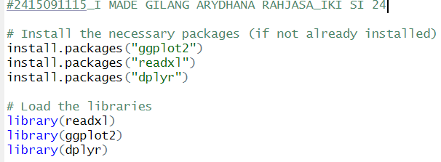

This is the code to install the required packages where readxl to read data files in excel, dplyr for fast, efficient data manipulation, and ggplot2 to visualize the results of the data analysis.

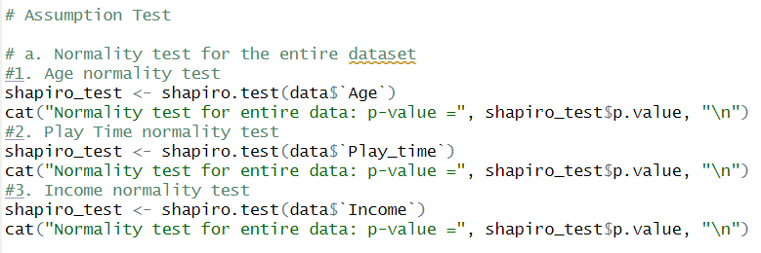

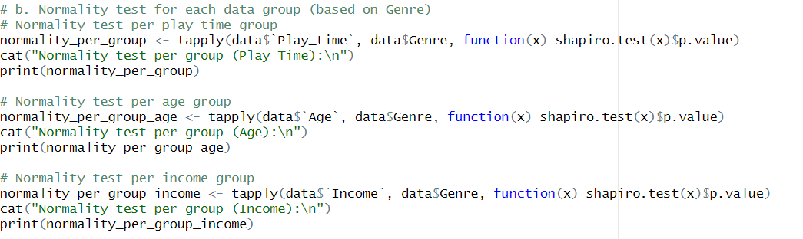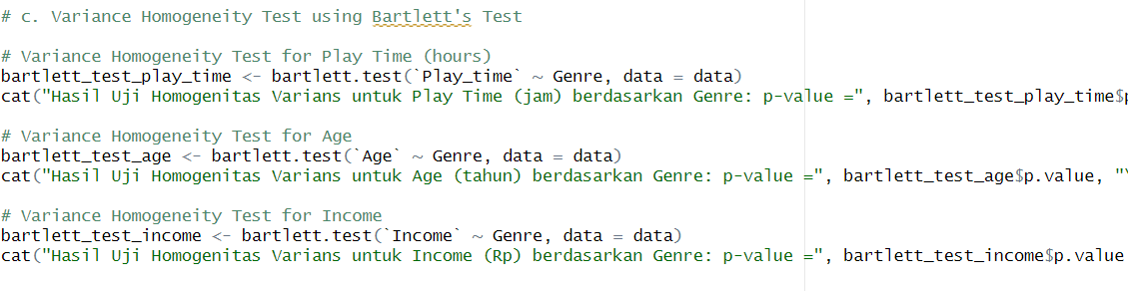

3 This code is the assumption test that I did where the first assumption test is aimed at normality test for each data, then the second assumption test is normality test for each group data based on genre and the last is variance test.

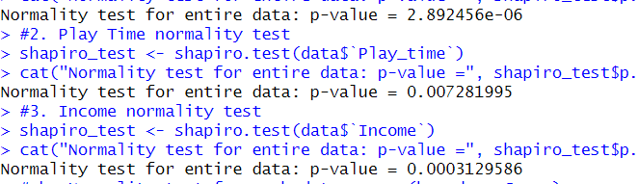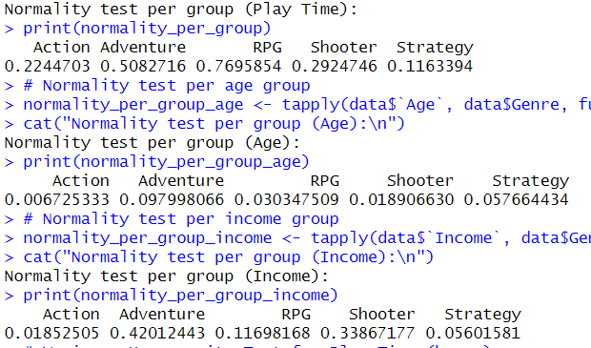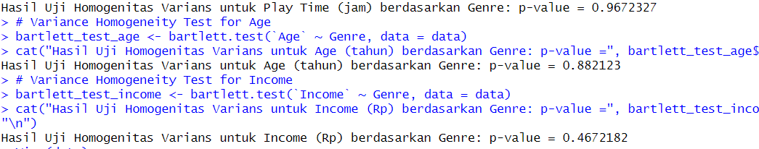

This is the result of the code

* 1. Normality test entire data
     1. Normality test for entire data(Age) : p-value = 2.892456e-06 (normal distribution)
     2. Normality test for entire data (Play_time): p-value = 0.007281995 (normal distribution)
     3. Normality test for entire data (income) : p-value = 0.0003129586 (not a normal distribution)
  2. Normality test per group
     1. Normality test per group (Play Time):

Action Adventure RPG Shooter Strategy 0.2244703 0.5082716 0.7695854 0.2924746 0.1163394

* + 1. Normality test per group (Income):

Action Adventure RPG Shooter Strategy 0.01852505 0.42012443 0.11698168 0.33867177 0.05601581

* + 1. Normality test per group (Age):

Action Adventure RPG Shooter Strategy

0.006725333 0.097998066 0.030347509 0.018906630 0.057664434

* 1. Variance Homogeneity Test using Bartlett's Test
     1. Hasil Uji Homogenitas Varians untuk Play Time (jam) berdasarkan Genre: p-value = 0.9672327 (homogen)
     2. Hasil Uji Homogenitas Varians untuk Age (tahun) berdasarkan Genre: p-value = 0.882123 (homogen)
     3. Hasil Uji Homogenitas Varians untuk Income (Rp) berdasarkan Genre: p-value = 0.4672182 (homogen)

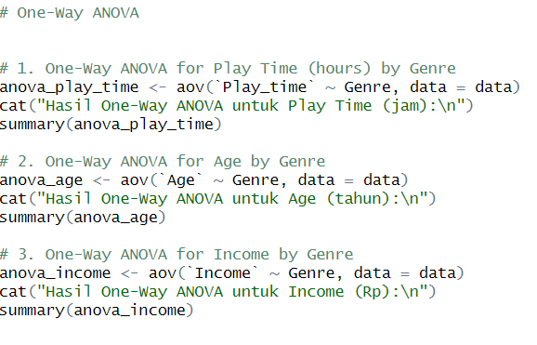

This code is to analyze anova with one way anova where I analyze 3 groups of data based on genre, starting from play time, age, and income.

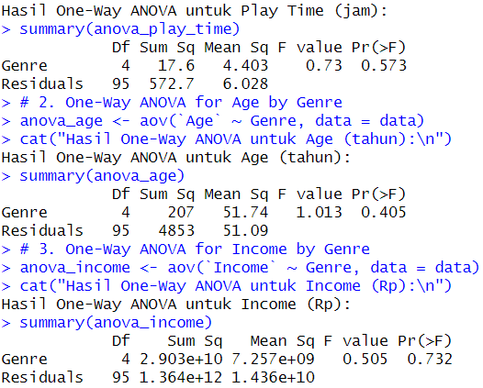

And this is the result of the one way ANOVA

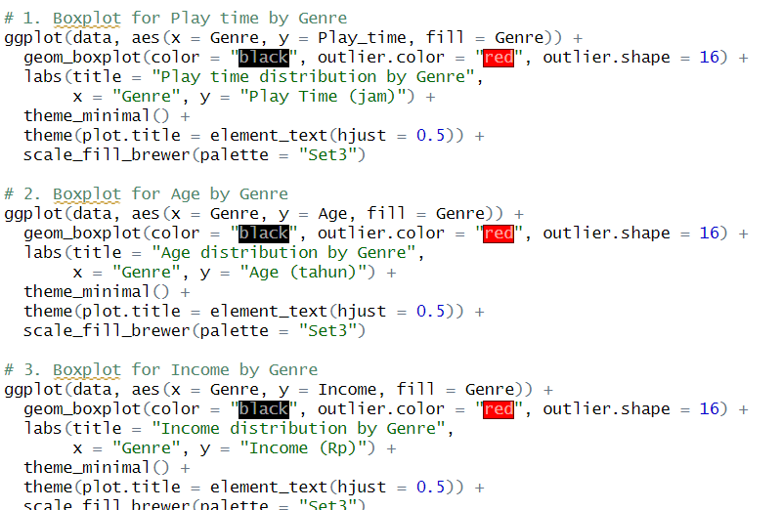

This is the visualitation code of the one way ANOVA

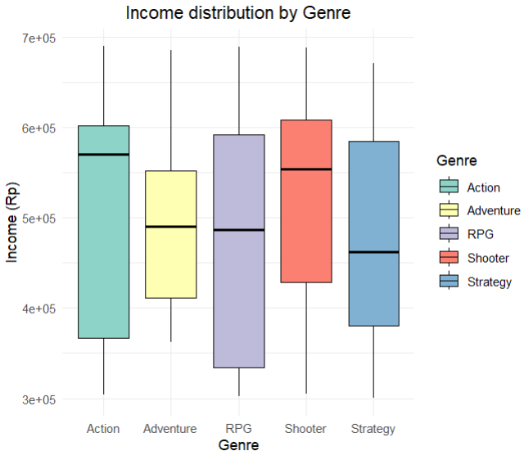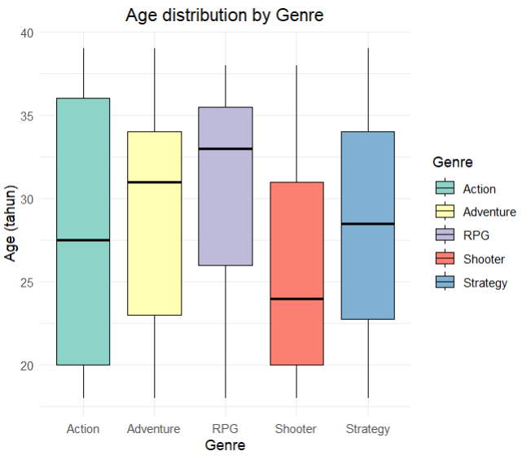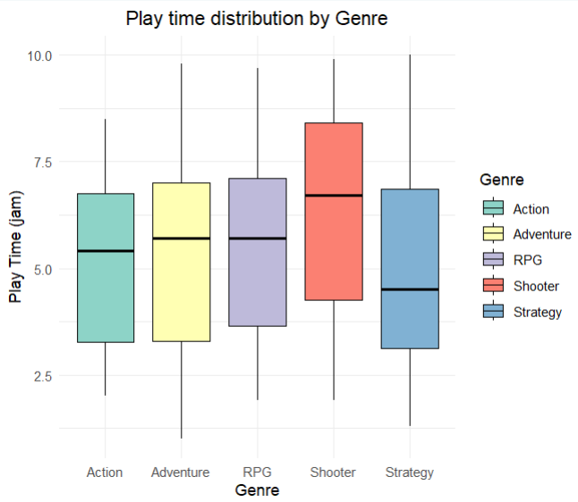

This is the visualitation

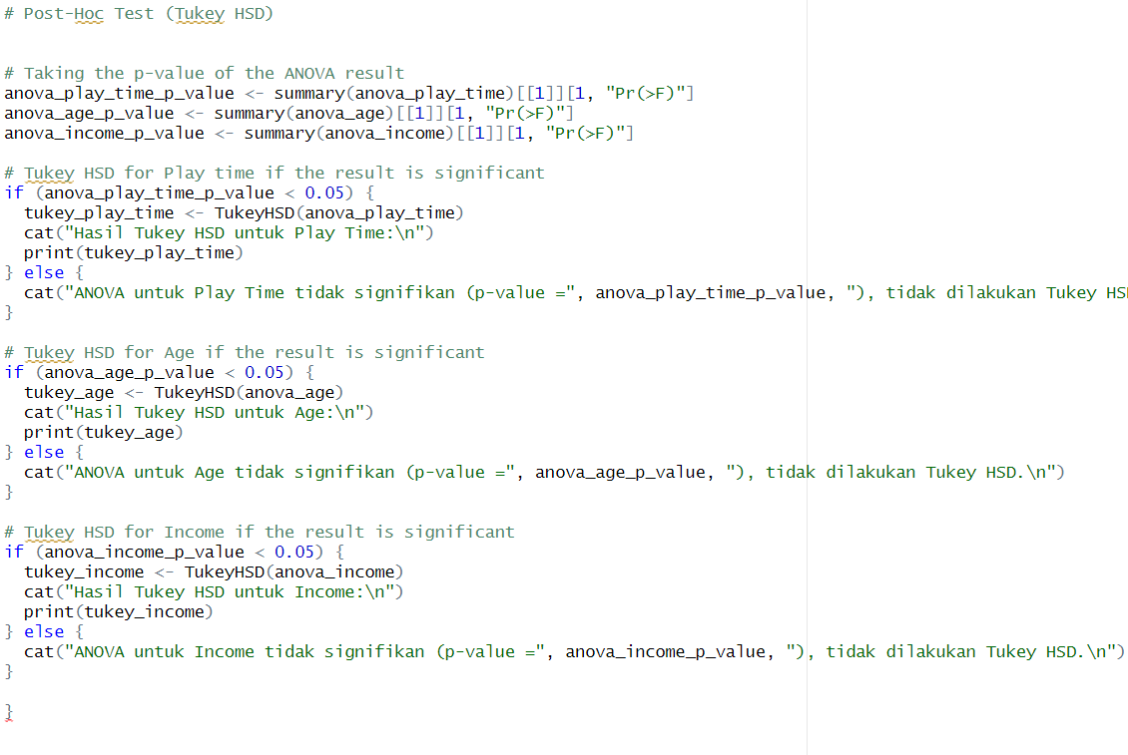

This is Post-Hoc Test (Tukey HSD) for check the ANOVA whether significant or not, where I also checked for the 3 ANOVAs that I had made

THE RESULT

1. ANOVA for Play Time was not significant (p-value = 0.5733393), no Tukey HSD was performed.
2. ANOVA for Age was not significant (p-value = 0.404841), no Tukey HSD was performed.
3. ANOVA for Income was not significant (p-value = 0.7318369), no Tukey HSD was performed.